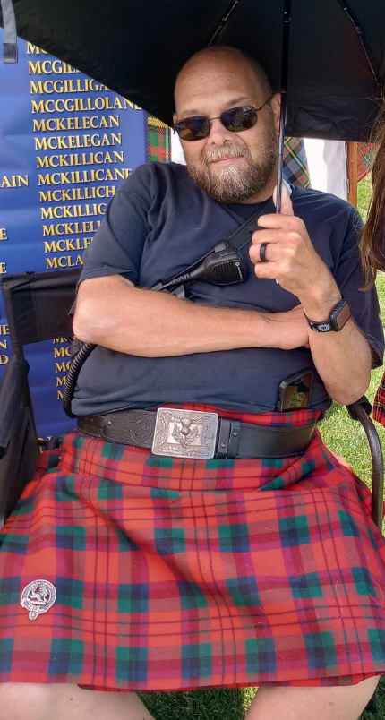
Todd Baker
Clan MacLellan and Clan MacDuff
November 30, 1977 - July 13, 2025
Todd's life was a testament to dedication and profound passion. A committed first responder, he approached every aspect of his life with wholehearted devotion. Beyond his selfless service, Todd found joy in scuba diving, the thrill of haunted houses, the camaraderie of BBQing, and the unique excitement of jousting.
He was known for his incredible kindness and caring nature, always prioritizing others. Even while battling his own illness, Todd consistently reached out, demonstrating his unwavering concern for the well-being of those around him. He is survived by his beloved wife, Daylin. Todd's compassionate spirit and unwavering dedication will be deeply missed by all who knew him.

